

**Boston University**

**Electrical & Computer Engineering**

**EC464 Capstone Senior Design Project**

**Final Testing Plan**

**The Art of Valuation**

by

Team 30

DevUp

Team Members

Prithika Ganesh pvganesh@bu.edu

Ignacio Nunez Gomez inunezg@bu.edu

Suyash Bhatia suyashb@bu.edu

Zen Mae Lee leezm@bu.edu

**Required Materials**

Software:

* Emulators: XCode
* Languages: ReactNative and Python 3
* Frameworks: Flask (Python)
* Data APIs and API keys: IEX Cloud Apperate

Hardware:

* Personal computing device i.e. laptop, PC etc.

**Set Up**

The setup requires running the frontend and backend code on an iOS emulator. The Visual Studio Code IDE will be used as our main platform.

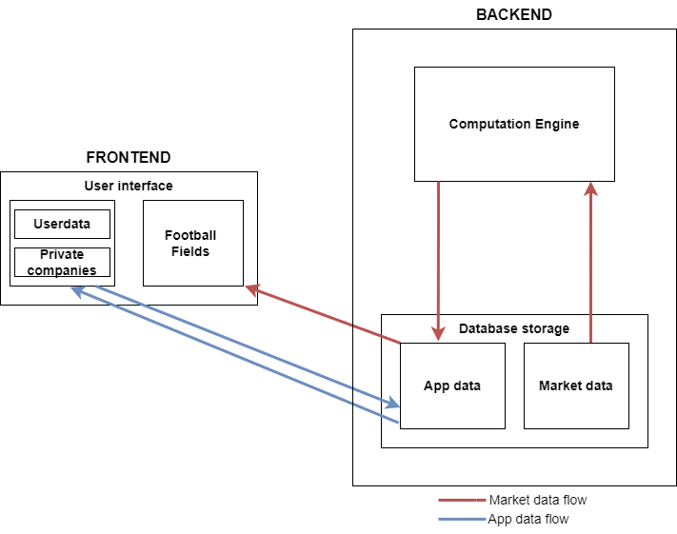

*Figure 1: Illustration of Data Flow from Backend to Frontend*

**Testing Procedure**

1. For the frontend, open Visual Studios and navigate into the *workshopfinance* directory.
2. Change directory to the frontend (i.e. cd frontend) and run the XCode emulator by typing ‘npm start’ → ‘i’ for iOS.
3. Change directory to the backend (i.e. cd backend) and run the routes.py file (i.e. python routes.py) in a new terminal to initiate running the backend.
4. Open the IEX Cloud database to demonstrate that our database and tables are designed and functional.
5. App will be open to the Sign In/Sign Up page. Create an account for the user by clicking “Register Now”. Fill in first name, last name, email address, password, and confirm password. Hit submit to create account.
6. Navigate to the Sign In page. Fill out just created account information. Hit submit.
7. Upon submission, you will arrive at the home screen with “Coverage” and “Profile” options. Click on “Coverage” to navigate to the “Coverage” page.
8. Create a Public Target.
9. Add a Football Field to that Target.
10. Create and add one valuations to the Football Field.
11. Add individual Comps to this valuation. Select different companies and adjust multiples to create different Comps. (Refresh login to see updates.)
12. Show that they have been added to the database.
13. Repeat steps 11 and 12 as many times as desired.
14. Show the latest football field to see the complete football field.
15. Navigate to the Coverage page to see a list of Football Fields.
16. Navigate to the Profile page to show user information.

**Measurable Criteria**

| **Action** | **Category** | **Y/N?** |
| --- | --- | --- |
| Flask working properly (routes.py) running smoothly | Backend |  |
| Open IEX Cloud database UI to display updates and design | Backend |  |
| IEX Cloud database functional:  Adding rows to tables using REST Api | Backend |  |
| Football Field name updated automatically in database | Backend |  |
| Application runs smoothly on iOS emulator | Frontend |  |
| Successfully creates new user account | Frontend |  |
| Can successfully sign in with new user account | Frontend |  |
| Creates a valuation | Frontend |  |
| Visual bars are adjusted for multiples selected | Frontend |  |
| Creates a successful “comp”from multiple valuations | Frontend |  |
| Valuation charts drawn with data from database | Frontend |  |
| Coverage page lists different Football Fields created | Frontend |  |
| User profile page shows user information | Frontend |  |
| **Result** | | % |